Project Title and Project Number are mandatory if the change relates to a project change. If the document is simple system documentation, these fields are not required. All other fields are mandatory

STRATEGIC ORIGINATIONS

A28003901

Direct Design Guidance

Document Owner:
Document Author: Craig Harley
Document Reference:
Document Status: Peer Review
Version:0.2
Version Date:02/02/2017
Creation Date:15/12/2016

Security Classification:
Date:
Owner:


Contents

1 Introduction 3
1.1 Version History 3
1.2 References 3
1.3 Glossary 3
2 Service Design Principles 4
2.1 Base principles 4
2.2 Guidelines for reducing the impact of change 4
2.3 Delivery opportunities 4
3 What Is Direct Design? 5
4 Modelling Work 6
4.1 BOM and DMD modelling work 6
4.2 IDM modelling work 6
4.3 Enumerations 6
4.4 SDM modelling work 7
5 Conventions Used 11
5.1 Service Operation Naming 11
5.2 The difference between attributes and types. 11
6 Direct Design Principles 13
6.1 Request/Response Principle 13
6.2 Enumeration Principle 13
6.3 Identifier Principle 14
6.4 Re-Use Principle 15
6.5 Sub-Typing Principle – could be replaced by Choice Element vs Polymorphism Principle 15
6.6 Flattening Principle 16
6.7 Redundancy Principle 19
6.8 Variant Transfer Object Principle 20
6.9 Choice Element vs Polymorphism Principle 21
7 Notes 24

Introduction
This document describes the new modelling approach required when approaching Service or Process Design. For the purposes of this document;
- Service (ESB) will refer to the over-arching service e.g. InvolvedPartyManagement
- Operation will refer to the operations of that Service e.g. RetrieveInvolvedPartyDetails
- Process Group will refer to the overarching Process e.g. ArrangementNegotiation
- Process refers to both the individual STPO’s and LRPO’s contained within a Process Group e.g. ActivateDepositArrangement and AdministerOfflineAccountOrigination respectively
- Business Rule refers to an ODM rule e.g. EvaluateBureauResponse

Version History
Version | Description
0.1 | Version for peer review
0.2 | Updated following peer review

References
Ref. No. | Document | Version | Description | Link

Glossary
Name | Description
BOM | Business Object Model
DMD | Design Model Datatypes
ESB | Enterprise Service Bus
HTTP | Hyper Text Transport Protocol
IDM | Interface Design Model
ODM | Operational Decision Manager: The IBM rule engine product.
JSON | JavaScript Object Notation
LRPO | Long Running Process Orchestration
MQ | Message Queue
MSMQ | Microsoft Message Queuing
REST | RESTful API
SDM | Service Design Model
SOAP | Simple Object Access Protocol
STPO | Straight Through Process Orchestration

Service Design Principles

Base principles
- Software components should be built to available requirements and SOA Services are no different. Trying to predict future project requirements when performing the design and build of Services leads to ‘analysis paralysis’ and rarely delivers components that are any more likely to be re-use without change.
  - History shows that organisations can expend significant time analysing what extra should be done to meet potential future requirements.
- Therefore, it is not recommended that we try to predict future project requirements when performing service analysis, design or build.
- However, pragmatic generalisation principles can be applied to Service design to make change easier and/or less likely. These principles focus on ensuring the right type and quantity of logic appear in a service rather than predicting requirements.

Guidelines for reducing the impact of change
- Services should be stateless
- Service must be versioned and support ‘side-by-side’ deployment. That is, they must support multiple concurrent versions in production
- Services changes must be possible without impacting consumers.
- Services should be composable, i.e., a new Service can be composed from other Services.
- Service interfaces should be based on Nationwide’s standard data model (based on IFW)
- Security logic (authentication & authorisation) should be separate from business logic
- The way a consumer interfaces with a Services should be standards based, i.e., SOAP, JSON/REST, HTTP, MSMQ and MQ.
- Service interfaces should only define data required for their correct operation.
- Services should be designed and built to a defined set of patterns, e.g., Request/Reply, Assured Delivery, etc.
- Overlap: minimising the overlap between the scope of different services, and the data they deal with.
- Cohesion: operations within a service should relate to one another and are likely to change together.
- Granularity: a service should have sufficient responsibility to warrant being managed as a component of its own right

Delivery opportunities
- Once project requirements for Service creation or change have been identified, consideration should be given to other projects operating in the same space. To avoid unnecessary versions of a service, opportunities to consolidate requirements to deliver a single code drop should be explored.
- A ‘factory’ approach utilising code-generation and componentisation should be used to reduce the cost of future iterations of Services.

What Is Direct Design?
At a glance, Direct Design encompasses the following;

- A “back-to-basics” approach to designing service schemas
- During integration design, A&D inputs are used to directly design transfer object models in RSA.
- Schemas will be self-contained. WSDLs and XSDs are to serve as near-complete service interface specifications.
- The terms in the XSDs are based on the same common language as the requirement has been expressed in (e.g. the BOM).
- Where complex data requirements arise, base models (e.g. the BOM) and other service Transfer Objects can be used to guide service design decisions.
- “Direct Design” recognises that different types of service operation require different design approaches.
- The Transfer Objects will not be automatically generated from other models.
- There are different options available with regards to ensuring that Transfer Objects are consistent with one another.

Modelling Work

BOM and DMD modelling work
The working method in these models will not change and will continue to be modelled using the same approach.

IDM modelling work
A decision was made that the IDM should be phased out. The reasoning behind this was that it was an extra overhead that brought little or no value to the Integration Design process. The implications of this change are as follows;
When creating a new Service, Process or Rule, relationships from each of the individual elements, such as the Transfer Object or Attribute should no longer refer to the IDM, but instead to the BOM directly via a <<derive>> relationship.
When updating an existing Service or Process, any existing relationships to the IDM should be changed to point to the BOM Directly. Rules are new and as such already have direct relationships to the BOM.

Enumerations

New Enumerations
New enumerations will be located within the Transfer Object Folder of the Service, Rule or Process Group if it is not used by any other Service, Rule or Group
e.g. EvaluateBureauResponse Rule uses a new enumeration unique to its operation located at B_SDM::uk::co::nationwide::Services::ODM::EvaluateBureauResponse::v1::Transfer Objects::Enumeration

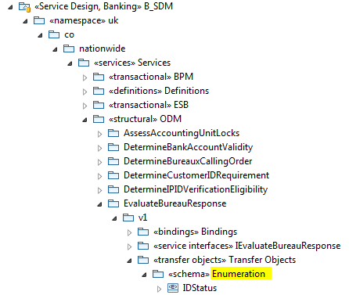

Where a new enumeration is to be used by multiple Services, Rules or Processes it is to be located at a more common level in the definitions folder e.g. Severity Type which is located at B_SDM::uk::co::nationwide::Services::Definitions::Enumerations

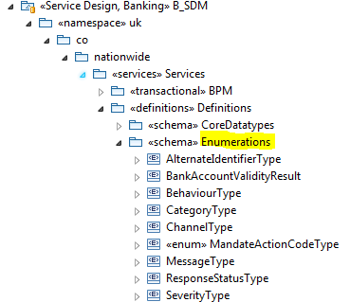

Legacy Enumerations
Originally enumerations were located within the IDM, but due to the planned retirement of the IDM they have all been relocated under B_SDM::uk::co::nationwide::Structural Components within their individual schemas
e.g. InvolvedPartyNameType is located within B_SDM::uk::co::nationwide::Structural Components::Involved Party::Enumerations

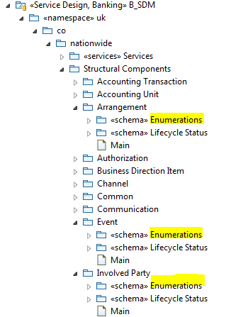

This is the approach taken for all legacy enumerations to move them out of the IDM until a change is made to the enumeration.
In the event that a legacy enumeration is to be updated it will be relocated appropriately as per the guidance for new enumerations.

SDM modelling work
This will mostly continue as is, but in the area of Transfer Objects will be the area most impacted by the new Direct Design approach.

Overview
Each Service (not Service Operation) will continue to have its own package in the SDM. This package will contain:
- A package for the bindings for the relevant service operations
- A package for each Operation, which will contain the ServiceInterface details and the Service Parameters (with the request and response messages)
- A package for the Transfer Objects used by the Service
- A participant for each Operation

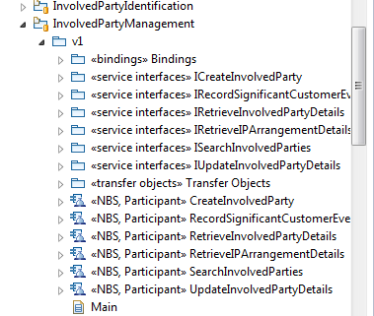
Figure 1: Structure of the Service packages in the SDM

Each Service will continue to have its own schema, derived from the Transfer Objects located within that Service’s package. This enables any changes to a Transfer Object for a particular Service to be self contained and not impact any other Services, Rules or Processes directly.

Old Method
Previously to ensure that Transfer Objects did not deviate from the canonical model, they could only be tailored in certain ways. The starting point for each Transfer Object would always be the corresponding IDM class, with no attributes in a Transfer Object that weren’t also in the IDM class. The Transfer Objects for each service would be tailored by:
- Removing attributes (or full Transfer Objects) that are not needed for the Service (Trimming)
- Modifying the multiplicity of any attributes within the Transfer Object

All attributes in the Transfer Objects would have a derivation relationship back to the IDM, otherwise traceability with the canonical model would have been lost.

New Approach
The new approach for Transfer Objects and their corresponding attributes is to use the Direct Design principles detailed in section 4
One key change is that the Transfer Objects and attributes will have a derivation relationship directly back to the BOM, instead of the IDM.

Adding a new Operation to an existing Service
- Locate the appropriate Service package for the Operation
- Add a new <<service interfaces>> package for the Operation. Within this package:
  - Create a <<service parameters>> package and define the request and response messages within this package. The <<service parameters>> package must have the <<schema>> stereotype applied, and the Element Form Default set to “qualified”.
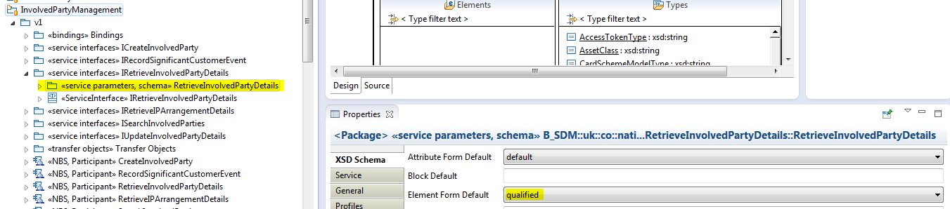
Figure 2: Example of a <<service parameters>> package with the schema stereotype applied and Element Form Default set to “qualified”.

  - Create the <<ServiceInterface>>, with the operation inside it referencing the request and response messages from the <<service parameters>> package. There should also be an abstraction back to the BOM from the operation.
- Create a Participant for the Operation, as per the convention set out in the MasterService package.
- Generate the SOAP binding from the Participant into the Bindings package.
- Perform Direct Design principles (detailed in section 4) when creating the Transfer Objects and attributes
- As this is adding a new operation to an existing Service model, careful consideration needs to be applied with the Direct Design approach to Transfer Objects and attributes as there are other operations using this model and there will be commonality between them.

Adding a new Service
There are currently two approaches:
- Copy (refactor) another similar Service package (or Master Service) and then tailor accordingly for the new Service (quicker, but more prone to errors when tailoring for Direct Design).
- Start from scratch creating a new Service package, and then create the required Transfer Objects based upon Direct Design Principles (detailed in section 4), correctly assigning namespaces as per Figure 3 (more time consuming, but will ensure a greater level of integrity in the model and will ensure only Transfer Objects that are absolutely needed will be included).

Whichever of the above two approaches is used, two things have to be ensured:
- All schemas for the Transfer Objects and the Operations have to be qualified.
- The Target Namespace and Target Namespace Prefix have to be correctly assigned as per the convention set out in the MasterService package (see example from Figure 3).

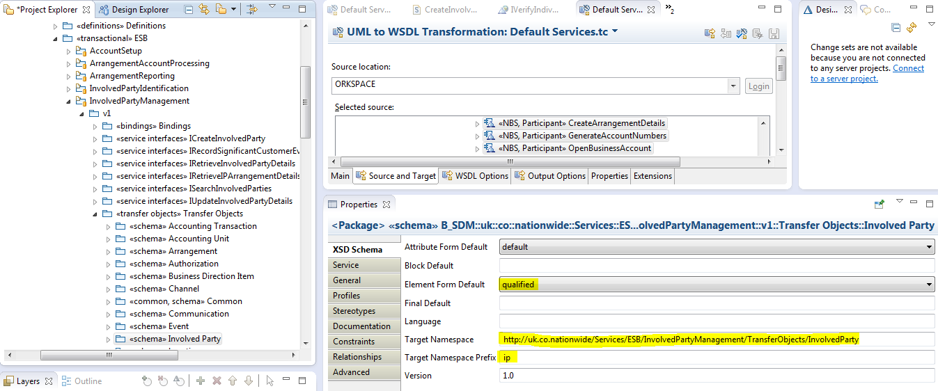
Figure 3: Example of the Namespace and Element Form Default definition of the InvolvedParty Transfer Object package.

UML2WSDL transformation
These will operate as before, with a Default and Create Services tc. The Participants will be selected from within the Service packages in the SDM, and the targets will be either the Default or Create folders within the appropriate NEMServices folder. The namespaces and bindings will still be defined in the SDM.

Conventions Used

Service Operation Naming
Service operation naming should be of the following format <Verb><Noun>.

- Valid verbs:
  - Create,
  - Retrieve,
  - Search,
  - Update,
  - Calculate,
  - Generate,
  - Verify,
  - Send,
  - Activate,
  - Determine.
- Don’t use:
  - Record,
  - Read,
  - List,
  - Modify,
  - Validate,
  - Check,
  - Fulfil,
  - Administer,
  - Apply.

- Valid Nouns: use the IFW components
  - “InvolvedParty”,
  - “Arrangement”,
  - “Product”
  - ……..
- Don’t use the word “Details”, as It adds no value.

The difference between attributes and types.

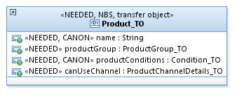
The above example of Product_TO contains 4 attributes:
- name
- productGroup
- productConditions
- canUseChannel

An attribute defines understandable values that are commonly grouped within a transfer object. They are generally named to describe what they are for, i.e. in the example above “name” represents the name of the product and will have the same or similar name within the Use case.
Each attribute is defined to be of a specific type,
i.e in the example above “name” is a simple type of String, whereas the other 3 are all transfer object types, which can also contain attributes.
i.e. “productConditions” is of type Condition_TO, which in turn contains 2 attributes

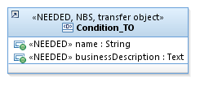

Direct Design Principles

Request/Response Principle
If a request/response message for a service operation contains 1 or 2 parameters relating to a particular object, then leave as is, otherwise if there are more than 2 related parameters consider creating a service specific Transfer Object.

For example:
A requirement for a new Service Operation needs the following parameters as part of the request message:
Customer Name, Date of Birth, Customer Number, Account Number, Account Name, and Channel

- The first 3 attributes relate to an Individual, so a variant of the (master) Individual_TO would be created containing the Customer Name, Date of Birth and Customer Number attributes. It should be named something like Individual_<Qualifier>_TO, where <Qualifier> represents the Service Operation or describes the nature of the object, e.g. “Summary”. For example InvolvedPartyIdentification.verifyIndividualIdentification uses the Individual_VII_TO
- The next 2 attributes relate to an arrangement, but a separate Transfer Object will not be created for these, as in general, if there are two related attributes required then they should be two separate parameters on the message.
- Channel will remain as a separate parameter on the request message as it is not related to any of the other parameters

In summary the new request message will contain the following parameters;
- Customer (of type Individual_Summary_TO)
- Account Number (String)
- Account Name (String)
- Channel (String)

Enumeration Principle

When to create a Boolean in preference to an Enumeration datatype:
- If you have a datatytpe of only two items, the preference should be to use a Boolean, whose name starts with “is”. E.g. instead of “customerType: Enum (Existing, New)” have “isNewCustomer: Boolean” instead.
logic can be described in a more compact way i.e.
IF NOT isNewCustomer THEN, as opposed to IF customer type == “Existing” THEN.
There are exceptions where this doesn’t work well, e.g. Gender. (Although one could further argue there are more than two of these anyway.)

When to create a String in preference to an Enumeration datatype:
- If the datatype has potential to change, with an impact to the service then it should be a String. E.g. “BAVFailureOverrideReasonType: Enum (Customer Request, Third Party Request)” potentially could have another planned value in the future called “Branch Request”, the addition of this would change the logic and structure of the service, so it would be preferential to make BAVFailureOverrideReasonType a String

When to create an Enumeration datatype:
- If the datatype has no potential to change, with no impact to the service then it should be an Enumeration. E.g. “daysOfWeek:Enum (Mon, Tue, Wed……..)” would be an enumeration

Identifier Principle
The following are examples of Identifiers currently used;
- Customer Number (InvolvedPartyIdentifier_TO)
- Product ID (ProductIdentifier_TO)
- Account Number (CompoundIdentifier_TO)
- Arrangement Identifier (ArrangementIdentifier_TO)

Where an identifier is being used such as Customer Number, make it of type string, as the only relevant information needed is the identifier attribute within the Identifier Transfer Object Hierarchy which is used to hold a number in all subtypes of Identifier.
A second key point here is to tightly define the format of key identifiers, for example Customer Number is a string of x characters, the same would be true for Product ID e.t.c. (See Tightening Principle for further detail)
In the past this unnecessary hierarchy of InvolvedPartyIdentifier_TO and EnterpriseIdentifier_TO has been used, when in fact we are only interested in the identifier itself, i.e. the customer number. This is also applicable to other identifiers such as ProductIdentifier, ArrangementIdentifier and RegistrationIdentifier.
In general consider each attribute type and where possible use primitive data types

An example of the old hierarchy is IArrangementReporting.retrieveArrangementDetails
On the Request an arrangementIdentifier of type CompoundIdentifier_TO is used

In the service model the hierarchy is represented as follows
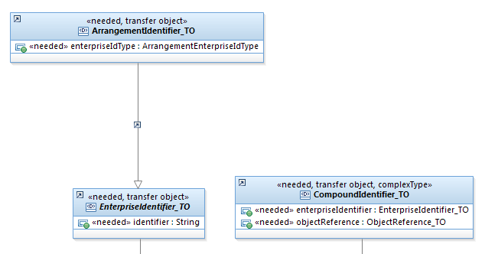

Using Direct Design, the arrangementIdentifier in the request message becomes a String and removes the need for the service model hierarchy shown above

Re-Use Principle
Where possible the re-use of common Transfer Objects should always be considered, e.g. aim to use Transfer Objects such as PostalAddressComponent_TO and IndividualName_TO without modification as these are considered truly transferable to many Services, Rules and Processes (i.e.no transformation would ever have to be done on these types since they would always be exactly the same)

For example in the case of IndividualName_TO, this should always contain the following attributes;
prefixTitle (0..1) Number04
firstName (1..1) String15
lastName (1..1) String30
middleNames (0..1) String

Further details on which Transfer Objects are considered common for re-use will be added to this section as they are identified

TransferObject | Description
Individual_TO | Identifies a particular type of <Involved Party> that is a natural person who is of interest to the modelled organization
IndividualName_TO | Identifies a name structure used to specify a particular <Individual> or an <Involved Party Role> played by an Individual.
PostalAddressComponent_TO | An individual component of a postal address e.g. City, Zip Code
PostalAddress_TO | An address used for the delivery of letters and packages by an external mailing or package service, at a place where the recipient usually lives or works
TelephoneNumber_TO | A communication point, as defined by the telecommunication services.  It includes voice, fax and other telephone communication
ElectronicAddress_TO | Identifies a particular type of <Contact Point> that is an electronic communication point used for routing messages to or from a particular <Role Player>.

Sub-Typing Principle – could be replaced by Choice Element vs Polymorphism Principle
Use of subtyping in the appropriate situation should be considered, e.g. if for instance a service operation would be introducing a service event concept, where there are multiple event types consider using a lightweight hierarchy.
In the example below for Customer Event Management;

A Transfer Object called CustomerEvent_TO which contains the common attributes of all the events is created, then create a Transfer Object per Event, such as InvolvedPartyReviewEvent_TO and MaintenanceTransactionEvent_TO, which contains attributes that are just specific to that event.
Depending on where the service is called from and what the expected event should be, then the CustomerEvent_TO can be subtyped to one of its children.

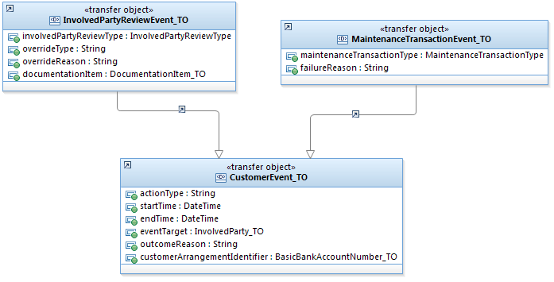

Flattening Principle
Using the previous IFW approach, after models have been trimmed, has left many layers of redundancy in the models. This principle should be used to determine when to:
- Roll up attributes from a Leaf Transfer Object to a Parent Transfer Object
- Roll down attributes from a Parent Transfer Object to a Leaf Transfer Object

For example a new service may require an individuals information returned in the response
Requiring 5 key areas of information: customer number, customer name, date of birth, gender and address
Using the previous IFW structure this would have been achieved using the following model structure.

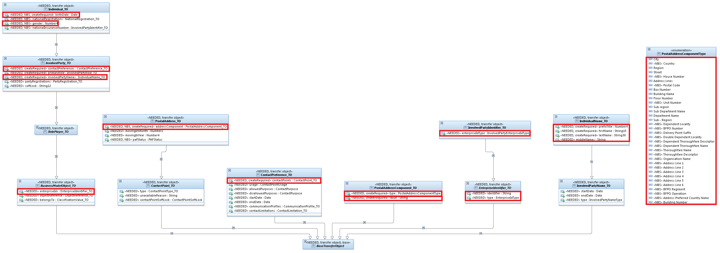

So from the individual (Individual_TO) in the response each required piece of information would be retrieved as follows:
gender = individual.gender
date of birth = individual.birthDate
customer number = individual.[InvolvedPartyIdentifier_TO]enterpriseIds.identifier
= individual.[InvolvedPartyIdentifier_TO]enterpriseIds.enterpriseIdType
customer name = individual.involvedPartyNames.prefixTitle
= individual.involvedPartyNames.firstName
= individual.involvedPartyNames.lastName
= individual.involvedPartyNames.middleNames
Address = individual.contactPreferences.[PostalAddress_TO]contactPoints.addressComponent.type
= individual.contactPreferences.[PostalAddress_TO]contactPoints.addressComponent.value

Using Direct Design Principles, we are left with the following

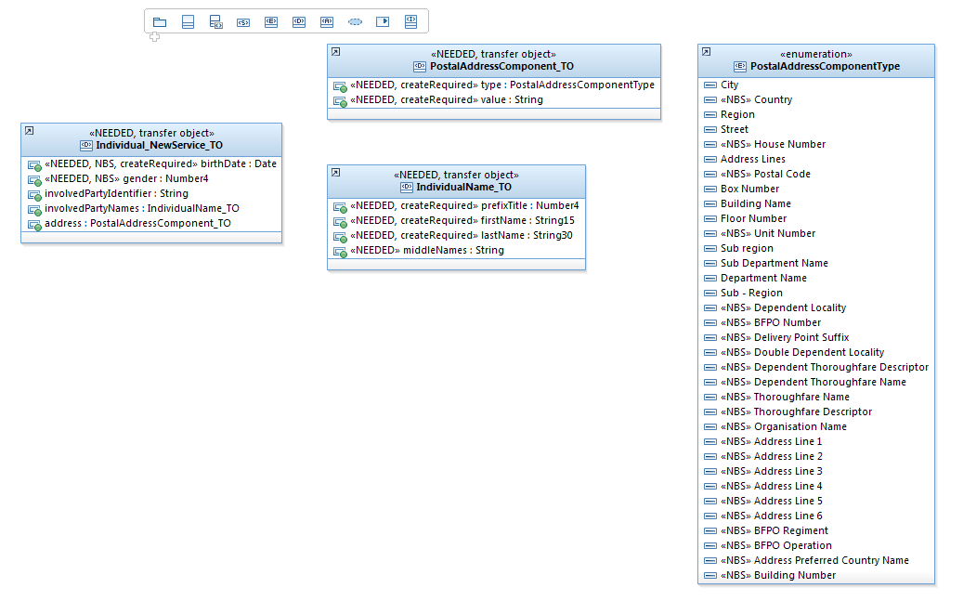
Using the Flattening principle (from parent to Leaf) involvedPartyNames, address and involvedPartyIdentifier have been rolled down into Individual_NewService_TO

However other priciples are also at work here:
Using the Request/Response principle we have 5 related attributes (associated with an individual), so a variant of Individual_TO has been created to hold all 5 related attributes, i.e. Individual_NewService_TO
Using the Enumeration principle the postalAddressComponentType has been left as an enumeration as its elements are highly unlikely to change
Using the Identifier principle the customer number (involvedPartyIdentifier) has been changed to a string type
Using the Re-use principle PostalAddressComponent_TO and IndividualName_TO have been left as is, as they are both commonly used objects
Using the Redundancy principle address (PostalAddressComponent_TO) is now an attribute within Individual_NewService_TO, so that ContractPreference_TO, ContactPoints_TO and PostalAddress_TO are no longer required.

An example of flattening from leaf to parent could be as follows from the existing model structure
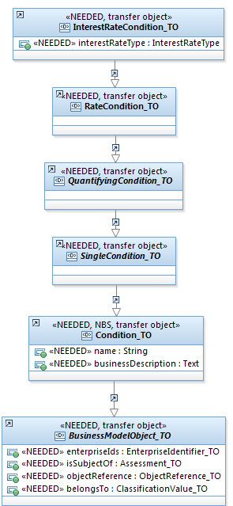

Name and businessDescription are required from Condition_TO, but interestRateType is also needed from InterestRateCondition_TO.
Potentially a decision could be made to roll up the single attribute from InterestRateCondition_TO and just be left with a Condition_NewService_TO with the 3 attributes described.

Redundancy Principle
Where an existing Transfer Object is being used by a Service, Rule or Process unless it requires to inherit something from the existing IFW hierarchy, then do not add in the hierarchy, i.e. keep it as a standalone Transfer Object.
An example of this could be as follows;
In the current model structure we have the following levels of inheritance

From the capability operation we require to have an attribute of type InterestRateCondition_TO. However after examination it is determined that the service operation is only interested in the name and businessDescription attributes contained within Condition_TO. In a scenario such as this it is worth considering changing the attribute type in the capability operation to be Condition_TO and eliminate 4 layers of inheritance.

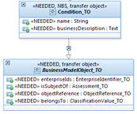

However please investigate the decision around the original typing of the attribute, as there may be a very good reason for its use.

Variant Transfer Object Principle
There may be a valid reason to create a variant of an existing Transfer Object, e.g. Individual_TO may need an additional 2 attributes and not need many of the existing ones. This is a perfectly valid approach to create an Individual_<ServiceName>_TO specifically for that purpose.
Whilst this custom TO may be copied by other services/process it is not intended that the TO is treated as some form as master, thereby the custom TOs in each service/process are treated completely separate from one another.

An example of this is IInvolvedPartyIdentification.VerifyIndividualIdentification which uses a variation of the Individual_TO Transfer Object

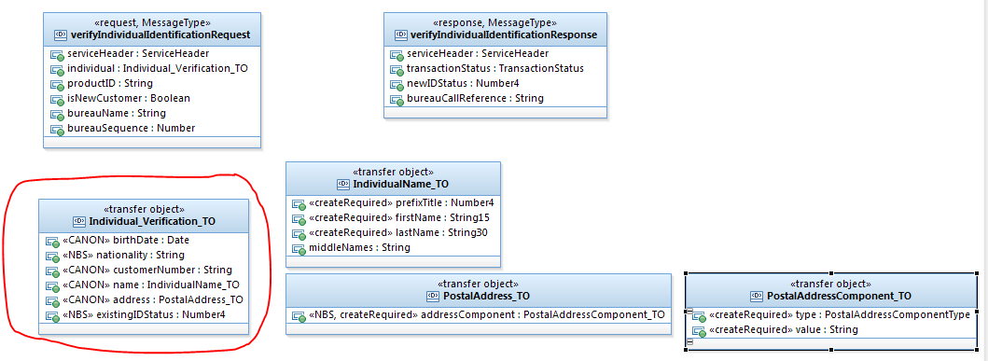

Which originally is as shown below
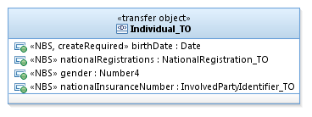

Another variation on this example is the AdministerOfflineIDCheck STPO which make a call to the AdministerIDVerification STPO. AdministerIDVerification expects an individual attribute of type Individual_AdministerID_TO in its request. Due to this, AdministerOfflineIDCheck aldo requires an internal Transfer Object called Individual_AdministerID_TO, which is populated and passed to AdministerIDVerification in the request message.

Tightening Principle – TBC
Where an attribute is defined as a string or number primitive type and the maximum length is also known, rather than just defining it as the base primitive type, define it as String12 or Number10. This may involve creating a new primitive type. The purpose of this tightening will help alleviate sql injection attacks.

In addition to this, also consider;
Should a string should actually be a string or whether it can be tightened further, i.e. it is only populated with letters and numbers, in which case change to an alpha numeric.
Are there specific special characters that can be used such as ‘@’ or ‘/’, in which case consider setting up a regular expression in the types Pattern field
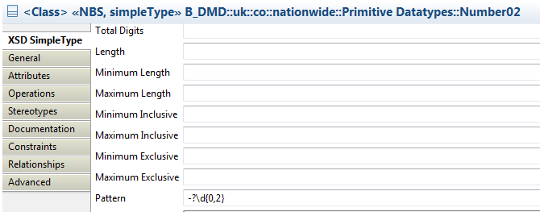

List of known attributes

Attribute | Type
Customer Number
Product ID

Choice Element vs Polymorphism Principle
This is an ongoing discussion, until a definite approach is decided this should be raised within direct design workshops for service/process design

Approach Discussion

[RS] Generally favour the former to keep the schemas tight and easy to understand.

[GL] In the AAAVO review we had suggested a choice would be an appropriate structure to use in AAAVO rather than inheritance, however I’ve just been trying add this to the SDM with Patrick.
The mechanism to do this is to add an anonymous nested class to within the base class and then set a stereotype on it indicating it is a choice (rather than the default of a sequence)
Unfortunately, all of the types in the SDM are data-types not classes so we cannot add this structure to these.

This is an unfortunate limitation of our model as choices are valuable structural constructs. This requires further investigation WRT options in the new year, but for now in Patrick’s design we have been forced to make both elements optional and enforce the mutual exclusivity by having a non-WSDL enforced validation.

We have a technical problem with choices in the SDM, at present. I’ll look into options to address this, but it might well be why we have so much inheritance in the first place. Can we remove mention of choices until we have a solution to implementing them in the SDM?

[RS] I’ve managed to do this in the past (with a limitation) and looked up my old notes that said you need to:
- Create a new datatype with stereotype “complex type”
- In stereotype properties, select a modelGroup of “1 – choice”
- Add attributes to this datatype of the types that would have been allowed if you had used polymorphism, and remove what you don’t need.
So it’s possible in our models if you define an explicit type that represents the choice. This is not great, but it is no worse than polymorphism which also requires an explicit type at the top of the hierarchy.

Have you tried the reverse engineering trick we discussed to see how XSD with choice elements are ingested into our models?

[GL] Yes I tried the reverse engineering trick, it created Classes not Data-types allowing the anonymous nested type

[RS] Why is the creation of classes an issue? Is this because the transformation tool does not process them?

Can one of you remind me, what was the AAAVO scenario we discussed here? If we have no exclusive choice element available, polymorphism could in some cases be a better design choice than having two optional elements with validation in the code

[PH] I can’t comment on the Data vs Classes issue too much, but I believe Graham’s issue was that we have so far modelled messages and TOs exclusively as Data Type items and not Classes, and Graham was nervous about deviating from this without understanding why we were doing it this way and what the consequences of the change would be.

But just to recap the scenario (for VAA STPO (formerly AAAV), not AAAVO), it is a fairly simple case where the STPO can be invoked with either a customer number or a complete set of individual details (in order to cater for both existing customer and new-to-group scenarios).

The “old fashioned way” we would have done this previously is to create a polymorphic Individual_TO and have logic in the process along the lines of “IF customer number present in Individual THEN [do thing], ELSE [do other thing]”. Note that this logic is identical for the process regardless of what we do here (and failure to provide one or the other will result in an error scenario regardless, whether via schema validation or a process-thrown error); the only advantage to enforcing conditionality on the interface is to make things clearer for someone reading our WSDL. As such we should be mindful of avoiding doing anything convoluted on the interface to enforce conditionality but which makes it more difficult to consume.

[RS] I agree with your point that we should balance being explicit in the schema, with having clear, unconvoluted, schemas. We have these options (titles underlined for readability ☺):
- An exclusive choice element is ideal: it is explicit in the schema, and it’s very clear. But if we can’t do this (I can’t believe it!), we need to consider the alternatives.
- We could create a new complex type (avoiding anonymous classes) to represent the exclusive choice. This is also explicit and clear, but we’re creating a type that would have otherwise been unnecessary.
- Runtime polymorphism generally causes convolution, nor is it explicit in the schema (as any subclass could be provided, not just the two we have in mind), plus it still has the same disadvantage as option 2, so indeed this may not be the best way forward.
- We could have a single individual TO with customer number and further details, make all fields optional, and define other validation behaviour in the design document (followed by defining it in the code, integration test documentation, and automated test evaluations). It is kind of clear, but you need to define it several times, resulting in defects.
- I was talking to Tomas today about design-time polymorphism vs runtime polymorphism. Design time polymorphism makes explicit which classes can inherit from the single superclass at design-time, making this explicitly visible in the schema. It is therefore possible to be explicit, and it’s clear also when you view such schemas in XML spy. It would require an additional RSA plugin (which I believe Tomas has installed), and some of Tomas’ time to explain. It still has the same disadvantage as option 2 though.

My order of preference would be 1, 2, 5, 4, 3.

[PH] Thanks Ruud. Currently I have this one modelled as per Option 2- The individual attribute is a complex type called Individual_Optional_TO, which has two conditional attributes- individual.customerNumber[String] and individual.details[Individual_Basic_TO].

Option 4 is probably closest to what we’ve been doing with Individuals so far this year- that is we have an Individual_TO with an optional enterpriseID representing the customer number (I know I know, don’t start) and a bunch of other optional attributes for fullName, birthDate, address etc., with the consumer expected to populate the many optional attributes smartly and the process rejecting where an incorrect combo of attributes is present.

As an aside, Craig mentioned that he recalls having this exact same debate way back at Increment 1, specifically around Option 1, and believes we came up against the same wall- our choice of Data Types over Classes. Unfortunately the decision to use Data Types in the first place predates both of us being on the team. It’s possible Mark Dombey will recall in more detail.

Design Time Polymorphism Discussion

[GL] Design time polymorphism had an advantage over runtime that advantage the allowed subtypes of a type are explicitly stated in the WSDL+XSD .
These are not assumed to be all subtypes of a type, which give the designer more control.

In XSD design time polymorphism manifests itself as substitution groups & global elements

There are 2 options for modelling design time polymorphism and a 3rd to manually add this to the WDL+XSD in post processing
- Manually add global elements & flag parents types as abstract in model
- Use the tool to automatically generate the globals & substitution groups in the WSDL XSD using an extension
- to manually change the XSDs after generation

- This would require adding new structures into the model to represent the globals and being stricter about flagging abstracts as abstract in the modelling work. (We should already be doing this, i.e. contact point should be an abstract class)

2)There are problems with the transform for design time polymorphism and the SDM model
This is likely due to duplicate named types, either just the name or the name and namespace. We are not sure which.
This transform would automatically create all globals for all the subtypes of a parent type which actually would not give the designer explicit control! Thus this does not seem to give us the advantage that we were seeking.

3)We could get design time polymorphism by manually adding substitution groups and global elements to existing process.
There are problems with this
- The details are not capture in the model
- It is not repeatable automatically. This might be possible to address with some automation.

My conclusion

Option 1) looks like the most promising potential benefit. I think the next step is to prototype this and explore how this can be implemented.
Organisation in the model. E.g. Should the globals be in the same schemas as the types?
Operationally how hard is it to make this work? Are there options to make the generation of the globals and the relationships easier for the designers.
Control? Can the scope of this be controlled per service?
Implementation? How do we add this to existing services? Do we need to wait for a major version change?

Notes

End of Document

From Rob Jackson, AMSB – 16-03-2016

